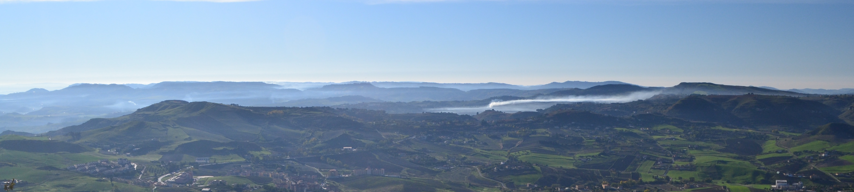
Young researchers in Structural geology and Tectonics
YORSGET 2022
Sicily June 30 – July 4, 2022
REGISTRATION FORM
First Name: | Last Name:
Affiliation:
Email: | Telephone number:
Contribution presentation | YES - NO
Oral presentation¨ | YES - NO
Title:
Registration fee until 30 March 2022 | ¨ € 210,00
Registration fee until 30 March 2022  Students/early career researchers (<10 years from PhD) | ¨ € 160,00
Registration fee from 30 March 2022 | ¨ € 260,00
Registration fee from 30 March 2022  Students/early career researchers (<10 years from PhD) | ¨ € 210,00
Social dinner | YES – NO € 40,00*
Accommodation
The discounted price for 4 overnight stay in Agrigento is 280 Euros in single room, 140 Euros in twin room. Participant must make their own hotel bookings contacting direct the hotel in Agrigento at the following address: mail@colleverdehotel.it- Subject: Booking 30 June 2022-4 July 2022 YORSGET -YOUR NAME AND SURNAME (organiser Maniscalco) by March 30th 2022.
* Social dinner – to be payed directly to the restaurant.
Please submit the registration form by March 30th 2022 to
rosanna.maniscalco@unict.it
martina.forzese@phd.unict.it

INFORMATION FOR BANK TRANSFER

Count n. 000400761309 Unicredit, Agenzia Roma 153 - Università Sapienza, ABI 02008 CAB 05227 IBAN IT 36P 02008 05227 000400761309 SWIFT o BIC : UNCRITM1153, addressed to Società Geologica Italiana.

Please send to SGI secretary (alessandro.zuccari@socgeol.it) information to address the receipt.

Registration congress fee includes:
Opportunity to present oral and/or poster contributions
Copy of the proceedings
Welcome icebreaker
Daily meals
Coffee breaks
Field Excursions of June 30th, July 1st, 4th, 2022.

Registration congress fee does not include:
What not expressly specified in the section "includes"
Public transportation out of Congress program (bus, taxi, etc.). Costs for overnight stays in hotel in Agrigento and Catania. Social dinner.

Important deadline
Early birds up to: 30th March 2022

The contributions are expected in English only, and can be oral (max. 12 min. + 3 min. discussion) or poster, based upon a selection by the Scientific Committee.

Only the Congress participants can submit summaries, contributions and posters.

To submit contributions and registration form, please email to: rosanna.maniscalco@unict.it
martina.forzese@phd.unict.it

